**AI-Driven Smart CCTV Surveillance System with Real-Time Detection and Facial Recognition Using Python and OpenCV**

**ABSTRACT**

The rapid advancement of artificial intelligence (AI) and computer vision technologies has paved the way for innovative security solutions. This project, titled "AI-Powered Security Camera System with Real-Time Anomaly Detection and Facial Recognition Using OpenCV and Machine Learning," focuses on developing a robust and intelligent security camera system. The proposed system leverages machine learning algorithms and OpenCV for real-time anomaly detection and facial recognition, aiming to enhance the efficiency of surveillance systems.

The proliferation of security cameras in public spaces has led to the development of smart CCTV surveillance systems, which can process live video feeds and detect security threats in real-time. These systems utilize advanced image processing techniques and artificial intelligence algorithms to analyze video data, identify suspicious behavior, and alert security personnel when necessary. Python is a popular programming language that is widely used in the development of smart CCTV surveillance systems due to its ease of use and powerful libraries for computer vision and machine learning. By leveraging Python, developers can quickly build complex video analysis pipelines that can perform a range of tasks, including object detection, tracking, and classification. One of the key benefits of

using Python in smart CCTV surveillance systems is its ability to work with opensource computer vision libraries such as OpenCV, which provides a wide range of tools for image and video processing. With these libraries, developers can quickly implement advanced algorithms for object detection and tracking, such as YOLO (You Only Look Once) and SSD (Single Shot Detector), which can detect objects

in real-time with high accuracy. Another advantage of using Python in smart CCTV surveillance systems is its ability to integrate with deep learning frameworks such as TensorFlow and PyTorch. With these frameworks, developers can train and deploy deep neural networks that can perform a range of tasks, such as facial recognition, crowd detection, and anomaly detection. Overall, smart CCTV surveillance systems using Python are becoming increasingly popular in a range of applications, from public safety and security to traffic monitoring and retail analytics. By leveraging the power of Python and its associated libraries and frameworks, developers can quickly build robust and efficient video analysis pipelines that can identify and respond to security threats in real-time. As such, smart CCTV surveillance systems are becoming an essential tool for enhancing public safety and security in an increasingly complex world.

**INTRODUCTION**

Surveillance systems have become a crucial element in ensuring public safety and security. With the rise in criminal activities, businesses and governments are constantly looking for ways to improve the effectiveness of their surveillance systems. In recent years, advancements in technology have made it possible to develop intelligent surveillance systems that are capable of analyzing large amounts of data and detecting unusual activity in real-time. This project report focuses on the development of a smart CCTV surveillance system using Python. The objective of this project is to design a smart CCTV surveillance system that can analyze video footage in real-time and detect unusual activities.

The system will use machine learning algorithms to learn from past events and identify patterns that could indicate potential threats. The system will also be able to alert security personnel in real-time, allowing them to respond quickly and efficiently to any potential security breaches. The system will be designed using Python, which is a high-level programming language that is widely used in the field of machine learning and artificial intelligence. Python provides a number of powerful libraries and frameworks that make it easy to develop intelligent systems. The project will make use of the OpenCV library for image and video processing, TensorFlow for machine learning, and Flask for web development. The system will be designed to be scalable and modular, allowing it to be easily adapted to different environments and configurations. The system will consist of a number of different components, including cameras, servers, and client applications. The cameras will capture video footage, which will be processed by the servers. The servers will use machine learning algorithms to analyze the video footage and detect unusual activity. The client applications will provide a user interface for security personnel to monitor the system and respond to any potential threats.

The system will be designed with privacy in mind, and will comply with all relevant privacy regulations. The system will only store video footage for a limited period of time, and access to the system will be restricted to authorized personnel. The smart CCTV surveillance system will provide a number of benefits over traditional surveillance systems. Firstly, the system will be able to detect unusual activity in real-time, allowing security personnel to respond quickly and efficiently to potential threats. Secondly, the system will be able to learn from past events and identify patterns that could indicate potential threats. Finally, the system will be scalable and modular, allowing it to be easily adapted to different environments and configurations. In conclusion, the smart CCTV surveillance system using Python is an innovative approach to improving public safety and security. The system will provide real time monitoring and detection of potential threats, while also being scalable and modular. The project report will provide a detailed overview of the system architecture, design, implementation, and evaluation. The report will also discuss the challenges faced during the development of the system and propose future directions for research and development in this area. Below are the different features of a smart cctv surveillance system:

1. Object Detection

2. Face Recognition

3. Intruder Alert

4. Person Counter

5. Wireless Transmission

6. Night Vision

7. Cloud Storage

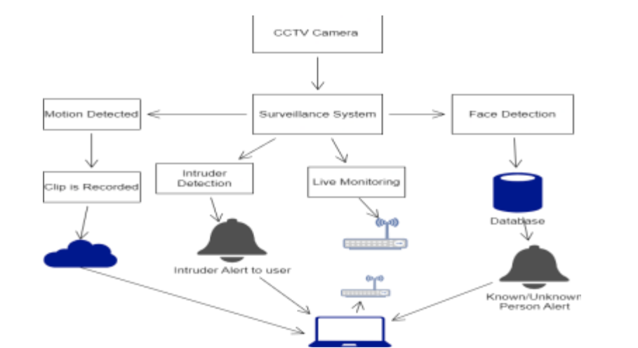

* 1. **FACE RECOGNITION:**

Face recognition technology has come a long way in recent years and has become an integral part of many modern security systems. One application of this technology is in CCTV surveillance systems, where it can be used to detect and identify people in real-time. In this project report, we will explore the use of Python for implementing a smart CCTV surveillance system that uses face recognition. Face recognition technology uses algorithms to identify and verify the identity of individuals based on their facial features. The algorithms analyze images or videos of faces and extract unique features such as the distance between the eyes, the shape of the nose, and the contour of the jawline. These features are then compared to a database of known faces to determine the identity of the person in question. The first step in implementing a smart CCTV surveillance system using face recognition is to acquire high-quality video footage of the area being monitored. This can be done using high-resolution cameras placed strategically in the area. The footage can then be processed using Python and OpenCV, a popular computer vision library.

OpenCV provides a set of tools for face detection, which can be used to identify and locate faces in the video footage. The library uses a technique called Haar cascades to detect faces. Haar cascades are classifiers that use machine learning algorithms to identify patterns in the image that correspond to faces. Once the faces have been detected, the next step is to extract the facial features using a technique called face landmark detection. This involves identifying key points on the face such as the corners of the eyes, the tip of the nose, and the edges of the lips.

The facial landmarks can then be used to calculate the unique features of the face. To identify the faces in the footage, the facial features need to be compared to a database of known faces. This can be done using machine learning algorithms such as Principal Component Analysis (PCA) or Linear Discriminant Analysis (LDA). These algorithms analyze the features of the faces in the database and create a mathematical model that can be used to identify new faces.

Once a new face has been identified, the system can perform a range of actions depending on the application. For example, in a security system, the system may send an alert to security personnel or automatically lock doors to prevent unauthorized access. In addition to security applications, face recognition technology has many other potential applications.

For example, it can be used in retail to track customer behavior and provide personalized recommendations based on their shopping habits. It can also be used in healthcare to monitor patients and detect signs of illness or distress. In conclusion, face recognition technology is a powerful tool that can be used in a wide range of applications. In this project report, we have explored the use of Python and OpenCV for implementing a smart CCTV surveillance system using face recognition. With the rapid advancement of technology, we can expect to see many more innovative applications of this technology in the future.

It is used to find if the person the frame is known or not. It can be done in two steps:

* Find the faces in the frames
* Use LBPH face recognizer algorithm to predict the person from already trained model.
* Detecting faces in the frames This is done via Haarcascade classifiers which are again in-built in OpenCV module of python.

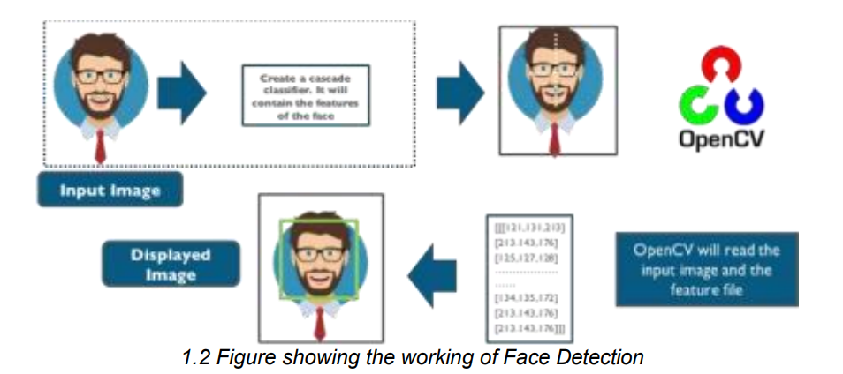

Cascade classifier, or namely cascade of boosted classifiers working with haar like features, is a special case of ensemble learning, called boosting. It typically relies on Adaboost classifiers (and other models such as Real Adaboost, Gentle Adaboost or Logitboost). Cascade classifiers are trained on a few hundred sample images of image that contain the object we want to detect, and other images that do not contain those images.

There are some common features that we find on most common human face

* a dark eye region compared to upper-cheeks
* a bright nose bridge region compared to the eyes
* some specific location of eyes, mouth, nose…

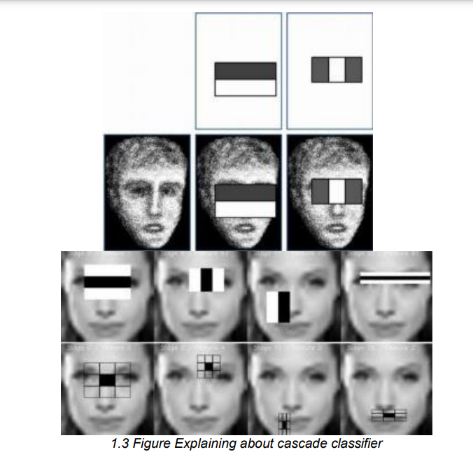

The characteristics are called Haar Features. The feature extraction process will look like this: Haar features are similar to these convolution kernels which are used to detect the presence of that feature in the given image. For doing all this stuff OpenCV module in python language has inbuild function called cascade classifier which we have used in order to detect for faces in the frame. Using LBPH for face recognition So now we have detected for faces in the frame and this is the time to identify it and check if it is in the dataset which we’ve used to train our lbph model.

The LBPH uses 4 parameters:

* Radius: the radius is used to build the circular local binary pattern and represents the radius around the central pixel. It is usually set to 1.
* Neighbors: the number of sample points to build the circular local binary pattern. Keep in mind: the more sample points you include, the higher the computational cost. It is usually set to 8.
* Grid X: the number of cells in the horizontal direction. The more cells, the finer the grid, the higher the dimensionality of the resulting feature vector. It is usually set to 8
* Grid Y: the number of cells in the vertical direction. The more cells, the finer the grid, the higher the dimensionality of the resulting feature vector. It is usually set to 8

The first computational step of the LBPH is to create an intermediate image that describes the original image in a better way, by highlighting the facial characteristics. To do so, the algorithm uses a concept of a sliding window, based on the parameters radius and neighbors. Which is shown perfectly via the above image.

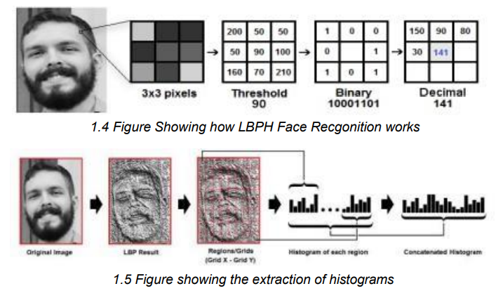

Extracting the Histograms: Now, using the image generated in the last step, we can use the Grid X and Grid Y parameters to divide the image into multiple grids, as can be seen in the following image: And after all this the model is trained and later onwhen we want to make predictions the same steps are applied to the make and its histograms are compared with already trained model and in such way this feature works.

* 1. **OBJECT DETECTION:**

Object detection is a fundamental computer vision task that aims to detect objects of interest within an image or video. It involves identifying and localizing objects within an image, and it is an essential component of many computer vision applications, including smart CCTV surveillance systems. A smart CCTV surveillance system is a system that incorporates artificial intelligence (AI) algorithms to improve its functionality, including the ability to automatically detect objects and events of interest. Python is a popular programming language for developing such systems due to its ease of use, large number of libraries and frameworks available, and its versatility for handling data and implementing machine learning algorithms.

Object detection in images and videos typically involves three main stages: image preprocessing, object detection, and post-processing. The image preprocessing stage involves preparing the input image or video frames for object detection, which may include resizing, normalizing, and color-space conversion.

Object detection is the stage where objects are detected within the image or video frames. Postprocessing involves refining the detected objects and removing any false positives. Object detection can be approached using different methods, including traditional computer vision methods and deep learning-based methods. Traditional methods, such as Haar cascades, use handcrafted features and machine learning algorithms to detect objects.

However, these methods can be limited in their accuracy and robustness, particularly for complex object detection tasks. Deep learning-based methods, on the other hand, use convolutional neural networks (CNNs) to learn features from the input data and perform object detection. These methods have shown superior performance compared to traditional methods and are currently the state-of-the-art in object detection.

One popular deep learning-based object detection method is the region-based CNN (R-CNN) family of algorithms. R-CNN algorithms involve dividing the input image into regions and processing each region separately to generate object proposals. The object proposals are then passed through a CNN to extract features, which are used to classify and refine the object proposals. This approach has been improved over the years with faster R-CNN, Mask R-CNN, and other variations that have achieved high accuracy on benchmark datasets such as COCO and PASCAL VOC.

Another popular deep learning-based method for object detection is YOLO (You Only Look Once). YOLO is a real-time object detection algorithm that can detect objects in an image in a single pass. It divides the input image into a grid and performs object detection on each grid cell to generate object proposals. YOLO has been improved over the years with YOLOv2, YOLOv3, and other variants that have achieved high accuracy and real-time performance.

Python provides many libraries and frameworks for implementing object detection algorithms, including OpenCV, TensorFlow, Keras, PyTorch, and others. These libraries and frameworks provide pre-trained models for object detection and can also be used to train custom models on specific datasets. They also provide tools for image and video preprocessing, post-processing, and visualization of object detection results.

In a smart CCTV surveillance system, object detection can be used to automatically detect and track objects of interest within the surveillance footage. This can include detecting people, vehicles, and other objects, as well as identifying events such as abnormal behavior or incidents. Object detection can also be used to trigger alarms or notifications, and to provide real-time insights into the surveillance footage.

Overall, object detection is a critical task for many computer vision applications, including smart CCTV surveillance systems. With the availability of deep learning based methods and the ease of use of Python libraries and frameworks, it is now easier than ever to implement object detection in a wide range of applications.

This uses Structural Similarity to find the differences in the two frames. The two frames are captured first when noise was not happened and second when noise stopped happening in the frame. SSIM is used as a metric to measure the similarity between two given images. As this technique has been around since 2004, a lot of material exists explaining the theory behind SSIM but very few resources go deep into the details, that too specifically for a gradient-based implementation as SSIM is often used as a loss function.

The Structural Similarity Index (SSIM) metric extracts 3 key features from an image:

* Luminance
* Contrast
* Structure

1.6 Flowchart showing how the monitoring works in CCTVThis system calculates the Structural Similarity Index between 2 given images which is a value between -1 and +1. A value of +1 indicates that the 2 given images are very similar or the same while a value of -1 indicates the 2 given images are very different. Often these values are adjusted to be in the range [0, 10 1],

where the extremes hold the same meaning. Luminance: Luminance is measured by averaging over all the pixel values. Its denoted by μ (Mu) and the formula is given below, Contrast: Contrast is defined as the difference between the highest and lowest intensity value of the frame. So, you can easily calculate it from respective histogram Structure: The structural comparison is done by using a consolidated formula (more on that later) but in essence, we divide the input signal with its standard deviation so that the result has unit standard deviation which allows for a more robust comparison. Luckily, thanks to skimage package in python we don’t have to replicate all this mathematical calculation in python since skimage has pre build feature that d o all of these tasks for us with just calling its in-built function. We just have to feed in two images/frames which we have captured earlier, so we just feed them in and its gives us out the masked image with score.

Features of the Intruder Alert System:

1. Real-Time Detection: The Intruder Alert system detects any suspicious activity or behavior in real-time. The system uses machine learning algorithms and computer vision techniques to analyze the video feed from the CCTV cameras.

2. Automatic Alerts: The system sends automatic alerts to the security personnel in case of any suspicious activity. The alerts can be sent via email, SMS, or other notification methods.

3. Multiple Camera Support: The Intruder Alert system can support multiple CCTV cameras simultaneously. The system can analyze the video feed from multiple cameras and provide alerts based on the detected activity.

4. Customizable Settings: The Intruder Alert system provides customizable settings that can be configured based on the specific requirements of the user. The user can set the sensitivity level, threshold, and other parameters to optimize the system performance.

5. Easy Integration: The Intruder Alert system can be easily integrated with other security systems such as access control, fire alarms, and other surveillance systems

Implementation of the Intruder Alert System using Python:

The Intruder Alert system can be implemented using Python programming language and various libraries such as OpenCV, TensorFlow, and Keras. OpenCV is a computer vision library that provides various algorithms for image and video processing. TensorFlow and Keras are machine learning libraries that provide tools for creating and training machine learning models.

The following steps can be followed to implement the Intruder Alert system using Python:

1. Video Capture: The video feed from the CCTV camera can be captured using OpenCV. The video feed can be stored in a video file or processed in realtime.
2. Motion Detection: The system can detect motion in the video feed using OpenCV. The motion detection algorithm can be used to identify any movement in the video feed.
3. Object Detection: The system can detect objects in the video feed using TensorFlow or Keras. The object detection algorithm can be used to identify any person, vehicle, or other objects in the video feed.
4. Alert Generation: The system can generate an alert in case of any suspicious activity. The alert can be sent via email, SMS, or other notification methods.
5. Customizable Settings: The system settings can be customized based on the specific requirements of the user. The user can set the sensitivity level, threshold, and other parameters to optimize the system performance.
6. Integration with other systems: The system can be easily integrated with other security systems such as access control, fire alarms, and other surveillance systems.

The real time alert module uses the information produced by the other modules, namely, object detection, tracking and classification to detect user specified alerts. The key feature of the real time alert module is its extensible design. Figure 1.7 shows the generic structure of the real time alert module. This structure is instantiated by most of the alert types. In order to illustrate the structure of the module we present the design of the directional motion alert as an example. The following processes are instantiated when the user specifies a directional motion alert.

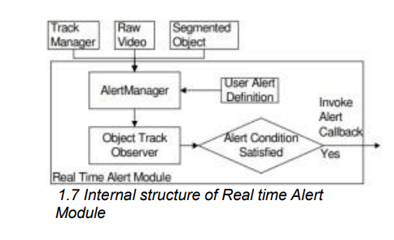

1. Directional Motion Alert Manager: Each motion alert user definition instantiates a directional motion alert manager, which is responsible for ensuring correct monitoring of the scene. The alert manager ensures that for every object being tracked there is a corresponding Object Track Observer that is instantiated. And that the Object Track Observer is deleted immediately upon the exit of the object from the scene.
2. Directional Motion Object Track Observer: This is the process that is charged with the job of measuring the direction of motion of the object and comparing it to the user specified direction. Whenever the object motion direction matches the user specified direction, the object track observer issues a real time alert. The application uses the alert to signal the user that one of the specified alert conditions has been met. Alert Manager Object Track Observer Track Manager Raw Video Segmented Object Alert Condition Satisfied Yes Invoke Alert Callback User Alert Definition Real Time Alert Module Figure 8: Internal structure of the real time alert module. The exact nature of the object track observer depends on the particular alert it is implementing. However, the general structure of many types of alerts is similar to that described above.
   1. VISITORS COUNTING:

This is the feature which can detect if someone has entered in the room or gone out. So, it works using following steps:

* It first detects for noises in the frame.
* Then if any motion happen it find from which side does that happen either left or right.
* Last if checks if motion from left ended to right then its will detect it as entered and capture the frame
* So, there is not complex mathematics going on around in this specific feature. So basically, to know from which side does the motion happened we first detect for motion and later on we draw rectangle over noise and last step is we check the co-ordinates if those points lie on left side, then it is classified as left motion.

**LITERATURE REVIEW**

Sagar Pandey, Sarah Irshad and Sanjay Kumar Singh, “Smart CCTV System”, Research Gate, 2021. At this time, one of the most crucial aspects of human life is security. Homes are frequently left unattended due to complex activities. Most individuals use CCTV (Closed Circuit Television) cameras to protect their homes when they are away from home. In smart cities, the footage captured by surveillance cameras is critical for crime prevention and investigation. Because the camera only records without analyzing objects, traditional Video surveillance is less effective. The sensor camera's purpose is to reflect progress in the motion of entities that are observable to the camera, in this situation, physical movements. This camera's reliable monitoring mechanism can detect approaching items. The adaptive background removal technology proposed in this paper can accommodate to frame changes. The prior background intensity inference will always be used to update the background frame. It will then analyze the method's effectiveness. Along with motion detection, it will only record moving frames, allowing the system to make the most of its capacity.

Dr. S. Hussain, “Smart Surveillance System using Thing Speak and Raspberry Pi”, Research Gate, 2015. This paper proposes the Smart Surveillance System using Thing speak and Raspberry pi. This design is a small portable monitoring system for home and office security. The model uses hardware mechanism such as Raspberry pi (model B), Gyro sensor and Raspberry pi camera. This system will monitor when motion detected, the Raspberry Pi will control the Raspberry Pi camera to take a picture and sent out an alert email with the image to the user by using Wi-Fi adaptor according to the program written in python environment. And at the same time the sensor real time data is visualized in the form of charts in Thing speak. The proposed system will work in standalone mode without the requirement of PC once programmed.

Amol V. Nagime and Patange. A. D , “Smart CCTV Camera Surveillance System”, International Journal of Science and Research (IJSR), 2016. The proposed work is Smart CCTV camera surveil-lance system. CCTV camera can be wirelessly monitored and control with the help of the RF module . In the monitoring site, the system captures the video through the embedded multitask operating system. The digital video has been compressed by the MJPEG algorithm. By the TV the users can view the monitors video directly, by the common Gateway interface, the users who are authorized can also control the camera and observe the motion detection.

Hampapur, Arun & Brown, L. & Connell, Jonathan & Pankanti, S. & Senior, Andrew & Tian, Y., “Smart surveillance: Applications, technologies and implications”, 2004. Smart surveillance, is the use of automatic video analysis technologies in video surveillance applications. This paper attempts to answer a number of questions about smart surveillance: What are the applications of smart surveillance? What are the system architectures for smart surveillance? What are the key technologies? What are the some of the key technical challenges? and What are the implications of smart surveillance, both to security and privacy?

K. Patel and M. Patel, "Smart Surveillance System using Deep Learning and Raspberry Pi” ,2021 8th International Conference on Smart Computing and Communications (ICSCC), 2021. Today, in the technological era of the 21st century, CCTV cameras have been proven to be very fruitful in our daily lives. From monitoring the baby in the bassinet to prevent some crimes, CCTV camera has become of vital importance. We as humans, always try to make things perfect around us. Using this article, we also have attempted to present our perspective to make these CCTV cameras more perfect. We have made an effort to enhance regular CCTV cameras using the vast field of deep learning and IoT. We have attempted to accomplish our goal by providing a protoStype for the smart surveillance system. We have tried to upgrade the regular CCTV cameras with some customized deep learning models developed by us. In this modified version, we have given the CCTV cameras the ability to detect fire and weapons. Also, we have tried to fulfil an ad-hoc requirement of Face Mask Detection considering the current situation of COVID19. For fulfilling our objective, we have provided an outline combining IoT (Raspberry Pi) to deep learning using AWS EC2 Cloud Architecture. To make the surveillance system user-friendly, we have also taken account of the client-side interface. Considering all the above applications, we have successfully provided an archetype in this paper.

S. U. Ahmed, H. Khalid, M. Affan, T. A. Khan and M. Ahmad, "Smart Surveillance and Tracking System," 2020 IEEE 23rd International Multitopic Conference (INMIC), 2020. This paper presents an intelligent system that can identify and recognize faces with applications, including a person's tracking, home surveillance, and private security. An automatic face recognition intrinsically handles security issues with flexibility - in the case of an unrecognized or unknown person, the real-time video stream is processed, motion is detected, and dual-axis pan-tilt servos track that person with a camera. Furthermore, such peculiar activities are video recorded with synchronization from cloud storage, and mobile alerts are generated. In the absence of the internet, a database file is developed with an audio notification to the security room if the anonymous face detected is not present in the database. Speech recognition and relay are also added for voice transmission and activation of surrounding lights. This project intends to substitute costly security systems using Raspberry pi 3B+ as the microcomputer.

**2.1 INFERENCES FROM THE LITERATURE SURVEY:**

The literature survey provides valuable insights into the current state of research and development in the field of smart CCTV surveillance systems. The surveyed papers suggest that smart surveillance systems have a wide range of applications, including home and office security, crime prevention, and investigation. Furthermore, it highlights that traditional video surveillance is less effective, as the camera only records without analyzing objects. However, smart surveillance systems use automatic video analysis technologies, such as motion detection and face recognition, to analyze video footage in real-time.

The proposed smart surveillance systems vary in terms of their hardware and software components, as well as their functionalities. For instance, the Smart Surveillance System using Thing Speak and Raspberry Pi proposed by Dr. S. Hussain uses a Raspberry Pi model B, Gyro sensor, and Raspberry Pi camera to monitor motion and send an alert email to the user with the captured image. The sensor's real-time data is also visualized in the form of charts in Thing Speak. On the other hand, the Smart CCTV Camera Surveillance System proposed by Amol V. Nagime and Patange A. D uses the RF module to wirelessly monitor and control the CCTV camera. The system captures digital video through the embedded multitask operating system and compresses it using the MJPEG algorithm. The users can view the monitored video through a TV, and authorized users can control the camera and observe motion detection through the common gateway interface.

Furthermore, the surveyed papers suggest that deep learning and IoT can enhance traditional CCTV cameras' functionality. For example, the Smart Surveillance System using Deep Learning and Raspberry Pi proposed by K. Patel and M. Patel enhances regular CCTV cameras using customized deep learning models. The modified version has the ability to detect fire, weapons, and face masks, making it suitable for use in the current COVID-19 situation. The system also uses IoT (Raspberry Pi) and AWS EC2 Cloud Architecture to make it user friendly.

Finally, the surveyed papers discuss the technical challenges of smart surveillance, including system architecture, key technologies, and security and privacy implications. For instance, Hampapur et al. (2004) discuss the technical challenges of smart surveillance, such as scalability, robustness, and integration with other systems. The paper also highlights the potential security and privacy implications of smart surveillance, such as unauthorized access to personal data and violation of privacy rights.

Overall, the literature survey suggests that smart CCTV surveillance systems have numerous applications and benefits, including improved security, crime prevention, and investigation. The proposed smart surveillance systems vary in terms of their hardware and software components and functionalities. However, they all use automatic video analysis technologies, such as motion detection and face recognition, to analyze video footage in real-time. The technical challenges of smart surveillance, including system architecture, key technologies, and security and privacy implications, need to be addressed to develop effective and secure smart surveillance systems.

**2.2 OPEN PROBLEMS IN EXIXTING SYSTEM”**

The field of smart CCTV surveillance systems is rapidly evolving and presents several open problems that researchers and developers are currently working on addressing. In this section, we will discuss some of the open problems in smart CCTV surveillance systems.

* **Privacy Concerns:** One of the major concerns with the implementation of smart CCTV surveillance systems is the violation of privacy. Smart surveillance systems use advanced technologies such as facial recognition, object detection, and tracking to identify and track individuals, which raises privacy concerns. There are concerns that these systems can be used for illegal surveillance or unauthorized monitoring, and there is a need to ensure that proper privacy regulations and laws are in place to protect individuals' rights.
* **Scalability:** Another significant issue with smart CCTV surveillance systems is scalability. The installation of CCTV cameras in public areas can be expensive, and it can be challenging to deploy these systems on a large scale. There is a need to develop cost-effective solutions that can be easily deployed in public areas without incurring high costs.
* **Real-time Analysis:** Traditional CCTV surveillance systems record video footage, which can be analyzed later. However, in smart surveillance systems, there is a need for real-time analysis of the captured video data to detect and respond to potential threats quickly. Real-time analysis requires advanced algorithms and processing power, which can be challenging to implement on a large scale
* **Integration with IoT:** The integration of smart CCTV surveillance systems with the Internet of Things (IoT) is another area of concern. Smart surveillance systems generate large amounts of data, and it is crucial to integrate these systems with IoT devices to ensure that the data can be efficiently processed and analyzed. Integration with IoT devices can also help improve the accuracy of the analysis and detection of potential threats.
* **Robustness:** Another open problem in smart CCTV surveillance systems is the robustness of the system. The system must be robust enough to handle challenging environmental conditions such as low light, changing weather conditions, and occlusions. The system must also be able to handle false alarms and prevent unnecessary alerts.
* **Power Consumption:** Smart CCTV surveillance systems require a constant power supply, which can be challenging in remote areas. There is a need to develop energy-efficient solutions that can operate using renewable energy sources such as solar power.
* **User-Friendliness:** Finally, the user-friendliness of smart CCTV surveillance systems is also an open problem. The system must be easy to use and operate, especially for non-technical users. The user interface must be intuitive, and the system must provide clear instructions and feedback to the user.

In conclusion, smart CCTV surveillance systems present several open problems that researchers and developers are currently working on addressing. These problems include privacy concerns, scalability, real-time analysis, integration with IoT, robustness, power consumption, and user-friendliness. Addressing these issues will require innovative solutions and collaborations between researchers, developers, and policymakers to develop effective and efficient smart surveillance systems that can improve public safety while ensuring privacy and security.

1. **SYSTEM ANALYSIS**

The system analysis for the Smart CCTV Surveillance System is a comprehensive breakdown of the functionality, architecture, technologies, and potential applications of this intelligent monitoring solution. Below is a detailed analysis encompassing all critical aspects of the system.

The Smart CCTV Surveillance System leverages cutting-edge technologies to enhance traditional video monitoring systems. By integrating artificial intelligence (AI), machine learning (ML), and advanced computer vision, this system addresses the increasing demand for proactive, automated security solutions in diverse environments.

* **Real-Time Threat Detection**: Identifying unusual or suspicious activities instantaneously.
* **Automation**: Reducing manual effort in surveillance by automating tasks such as object detection, face recognition, and intrusion alerts.
* **Scalability and Flexibility**: Ensuring the system is adaptable to various scales, from small offices to large public spaces.
* **User Accessibility**: Providing a user-friendly interface for managing, monitoring, and analyzing surveillance footage.
* **Data Security and Privacy**: Adhering to strict protocols to protect sensitive data.

**Functional Analysis:**

1. **Face Recognition**:

* Uses pre-trained models like Haar cascades or LBPH (Local Binary Patterns Histograms) to detect and recognize individuals.
* Matches detected faces with a pre-stored database of authorized personnel.
* Identifies and alerts security for unrecognized faces.

2. **Object Detection**:

* Detects and identifies objects using YOLO (You Only Look Once), SSD (Single Shot Detector), or Faster R-CNN algorithms.
* Classifies detected objects as human, vehicle, or other entities.

3. **Intruder Alerts**:

* Monitors restricted areas and generates alerts for unauthorized access.
* Sends real-time notifications via SMS, email, or dashboard alerts.

4. **Visitor Counting**:

* Tracks the number of individuals entering or exiting premises.
* Useful for crowd management and retail analytics.

5. **Motion Detection**:

* Detects movement in video feeds using techniques like background subtraction or Structural Similarity Index (SSIM).
* Distinguishes between minor environmental changes (e.g., shadows) and actual motion.

6. **Night Vision and Cloud Storage**:

* Ensures 24/7 monitoring with low-light enhancements.
* Stores video footage securely on cloud platforms for scalability and remote access.

**Architectural Analysis:**

**System Components:**

1. **Input Devices**:
   * CCTV cameras (IP-based or analog) for capturing video feeds.
   * Infrared cameras for low-light scenarios.
2. **Processing Unit**:
   * A central server or edge devices running Python-based algorithms.
   * Integrates machine learning models for data processing.
3. **Storage**:
   * On-premises servers for sensitive environments.
   * Cloud storage for scalability and remote access.
4. **Output Devices**:
   * User interfaces for monitoring video feeds.
   * Mobile and desktop notifications for alerts.

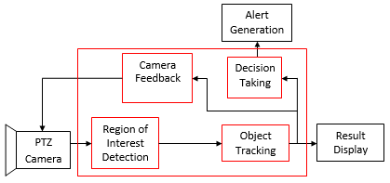

**System Flow**:

1. **Video Acquisition**:

* Continuous video capture from multiple cameras.
* Preprocessing (resizing, denoising) for efficient processing.

2. **Analysis**:

* Frames are fed into detection models for feature extraction.
* Algorithms detect faces, objects, or motion.

3. **Decision-Making**:

* Detected anomalies trigger alerts based on predefined rules.
* Alerts include sending emails, SMS, or activating alarms.

4. **Output and Storage**:

* Results are displayed on the dashboard.
* Data is securely archived for future retrieval and analysis.

**Use Cases:**

1. **Public Safety**:
   * Monitoring urban areas to detect criminal activities and manage crowds.
2. **Retail**:
   * Analyzing customer behavior for business insights.
3. **Healthcare**:
   * Monitoring patients remotely to detect emergencies or distress.
4. **Traffic Management**:
   * Identifying traffic violations and optimizing flow.

**Benefits**

* **Enhanced Security**: Real-time alerts ensure proactive threat mitigation.
* **Operational Efficiency**: Automates repetitive tasks, saving time and resources.
* **Data Insights**: Provides valuable analytics for decision-making.

**4. SOFTWARE ENVIRONMENT**

**Hardware Components**

1. **Cameras:**
   * **High-Definition IP Cameras:**
     + Resolution: At least 1080p (1920 x 1080 pixels) for clear image capture.
     + Features: Night vision capability (IR LEDs), wide-angle lens (minimum 90 degrees), and motion detection.
     + Connectivity: Ethernet for wired connections or Wi-Fi for wireless setups.
   * **Example Models:**
     + Hikvision DS-2CD2385FWD-I
     + Amcrest 4MP UltraHD IP PoE Camera
2. **Processing Unit:**
   * **Edge Computing Device:**
     + Specifications: A device with a dedicated GPU for real-time processing, such as NVIDIA Jetson Nano or Raspberry Pi 4 with a compatible AI accelerator.
     + CPU: Quad-core ARM Cortex or higher.
     + RAM: At least 4 GB (8 GB recommended for heavier processing loads).
   * **Desktop Workstation:** (for development and training)
     + CPU: Intel i5 or AMD Ryzen 5 or higher.
     + GPU: NVIDIA GTX 1060 or higher for deep learning tasks.
     + RAM: 16 GB or more.
     + Storage: SSD with at least 256 GB for faster data access.
3. **Sensors (optional):**
   * **Environmental Sensors:** (e.g., temperature, humidity, and motion sensors) to enhance monitoring capabilities.
   * **Microphone:** For audio detection to complement video surveillance.
4. **Network Infrastructure:**
   * **Router:** High-speed router to ensure reliable data transmission between cameras, processing units, and user interfaces.
   * **Network Switch (if wired):** To connect multiple cameras efficiently.

**Software Tools and Libraries**

1. **Programming Languages:**
   * **Python:** Primary language for developing the AI algorithms and integrating libraries.
   * **C++:** For performance-critical components, especially when using OpenCV.
2. **Libraries and Frameworks:**
   * **OpenCV:** Open-source computer vision library for image processing and computer vision tasks.
     + Version: 4.x or higher recommended for the latest features and optimizations.
   * **TensorFlow or PyTorch:** Popular deep learning frameworks for building and training machine learning models.
     + TensorFlow: Version 2.x or higher for robust support and community resources.
     + PyTorch: Version 1.x or higher for flexibility in model development.
   * **Scikit-learn:** For implementing traditional machine learning algorithms, if needed for additional analyses.
   * **Dlib:** For facial landmark detection and recognition, which can complement OpenCV for enhanced accuracy.
3. **Development Tools:**
   * **IDE:** Visual Studio Code, PyCharm, or Jupyter Notebook for Python development.
   * **Version Control:** Git for managing code changes and collaboration.
   * **Containerization (optional):** Docker for creating reproducible environments for development and deployment.
4. **Database Management System:**
   * **SQLite or PostgreSQL:** For storing recognized faces, logs of detected anomalies, and recorded footage metadata securely.
   * **Firebase (optional):** For real-time database capabilities and cloud storage solutions.

The successful execution of the cyberbullying prediction project relies on a robust set of tools and technologies that facilitate data collection, analysis, model building, and evaluation. This section outlines the key programming languages, libraries, and platforms used in the project.

**4.1 Introduction to Python**

Python is an interpreted, high-level, general-purpose programming language. Created by Guido van Rossum and first released in 1991, Python's design philosophy emphasizes code readability with its notable use of significant whitespace. Its language constructs and object-oriented approach aim to help programmers write clear, logical code for small and large-scale projects. Python is dynamically typed and garbage-collected. It supports multiple programming paradigms, including structured (particularly, procedural), object-oriented, and functional programming. Python is often described as a "batteries included" language due to its comprehensive standard library. Python was conceived in the late 1980s as a successor to the ABC language. Python 2.0, released in 2000, introduced features like list comprehensions and a garbage collection system capable of collecting reference cycles.

Python 3.0, released in 2008, was a major revision of the language that is not completely backward-compatible, and much Python 2 code does not run unmodified on Python 3. The Python 2 language, i.e., Python 2.7.x, was officially discontinued on 1 January 2020 (first planned for 2015) after which security patches and other improvements will not be released for it.[32][33] With Python 2's end-of-life, only Python 3.5.x and later are supported. Python interpreters are available for many operating systems. A global community of programmers develops and maintains CPython, an open-source implementation. A non-profit organization, the Python Software Foundation, manages and directs resources for Python and CPython development.

**SYNTAX AND SEMANTICS**

Python is meant to be an easily readable language. Its formatting is visually uncluttered, and it often uses English keywords where other languages use punctuation.

Unlike many other languages, it does not use curly brackets to delimit blocks, and semicolons after statements are optional. It has fewer syntactic exceptions and special cases than C or Pascal.

**INDENTION**

Main article: Python syntax and semantics § Indentation

Python uses whitespace indentation, rather than curly brackets or keywords, to delimit blocks. An increase in indentation comes after certain statements; a decrease in indentation signifies the end of the current block. Thus, the program's visual structure accurately represents the program's semantic structure. This feature is sometimes termed the off-side rule, which some other languages share, but in most languages, indentation doesn't have any semantic meaning.

**STATEMENTS AND CONTROL FLOW**

Python's statements include (among others):

The assignment statement (token '=', the equals sign). This operates differently than in traditional imperative programming languages, and this fundamental mechanism (including the nature of Python's version of variables) illuminates many other features of the language. Assignment in C, e.g., x = 2, translates to "typed variable name x receives a copy of numeric value 2". The (right-hand) value is copied into an allocated storage location for which the (left-hand) variable name is the symbolic address. The memory allocated to the variable is large enough (potentially quite large) for the declared type. In the simplest case of Python assignment, using the same example, x = 2, translates to "(generic) name x receives a reference to a separate, dynamically allocated object of numeric (int) type of value 2." This is termed binding the name to the object.

Since the name's storage location doesn't contain the indicated value, it is improper to call it a variable. Names may be subsequently rebound at any time to objects of greatly varying types, including strings, procedures, complex objects with data and methods, etc. Successive assignments of a common value to multiple names, e.g., x = 2; y = 2; z = 2 result in allocating storage to (at most) three names and one numeric object, to which all three names are bound.

Since a name is a generic reference holder it is unreasonable to associate a fixed data type with it. However, at a given time a name will be bound to some object, which will have a type; thus there is dynamic typing.

* The if statement, which conditionally executes a block of code, along with else and elif (a contraction of else-if).
* The for statement, which iterates over an iterable object, capturing each element to a local variable for use by the attached block.
* The while statement, which executes a block of code as long as its condition is true.
* The try statement, which allows exceptions raised in its attached code block to be caught and handled by except clauses; it also ensures that clean-up code in a finally block will always be run regardless of how the block exits.
* The raise statement, used to raise a specified exception or re-raise a caught exception.
* The class statement, which executes a block of code and attaches its local namespace to a class, for use in object-oriented programming.
* The def statement, which defines a function or method.
* The with statement, from Python 2.5 released in September 2006, which encloses a code block within a context manager (for example, acquiring a lock before the block of code is run and releasing the lock afterwards, or opening a file and then closing it), allowing Resource Acquisition Is Initialization (RAII)-like behaviour and replaces a common try/finally idiom.
* The break statement, exits from the loop.
* The continue statement, skips this iteration and continues with the next item.
* The pass statement, which serves as a NOP. It is syntactically needed to create an empty code block.
* The assert statement, used during debugging to check for conditions that ought to apply.
* The yield statement, which returns a value from a generator function. From Python 2.5, yield is also an operator. This form is used to implement coroutines.

The import statement, which is used to import modules whose functions or variables can be used in the current program. There are three ways of using import: import <module name> [as <alias>] or from <module name> import * or from <module name> import <definition 1> [as <alias 1>], <definition 2> [as <alias 2>],

The print statement was changed to the print () function in Python 3.

Python does not support tail call optimization or first-class continuations, and, according to Guido van Rossum, it never will. However, better support for coroutine-like functionality is provided in 2.5, by extending Python's generators. Before 2.5, generators were lazy iterators; information was passed unidirectionally out of the generator. From Python 2.5, it is possible to pass information back into a generator function, and from Python 3.3, the information can be passed through multiple stack levels.

**EXPRESSIONS**

Some Python expressions are similar to languages such as C and Java, while some are not:

Addition, subtraction, and multiplication are the same, but the behaviour of division differs. There are two types of divisions in Python. They are floor division (or integer division) // and floating point/division. Python also added the ** operator for exponentiation.

From Python 3.5, the new @ infix operator was introduced. It is intended to be used by libraries such as NumPy for matrix multiplication.

From Python 3.8, the syntax: =, called the 'walrus operator' was introduced. It assigns values to variables as part of a larger expression.

In Python, == compares by value, versus Java, which compares numeri’s by value and objects by reference. (Value comparisons in Java on objects can be performed with the equals () method.) Python's is operator may be used to compare object identities (comparison by reference). In Python, comparisons may be chained, for example a <= b <= c.

Python uses the words and, or, not for its Boolean operators rather than the symbolic &&, ||, ! used in Java and C.

Python has a type of expression termed a list comprehension. Python 2.4 extended list comprehensions into a more general expression termed a generator expression.

Anonymous functions are implemented using lambda expressions; however, these are limited in that the body can only be one expression.

Conditional expressions in Python are written as x if c else y (different in order of operands from the c? x : y operator common to many other languages).

Python makes a distinction between lists and tuples. Lists are written as [1, 2, 3], are mutable, and cannot be used as the keys of dictionaries (dictionary keys must be immutable in Python). Tuples are written as (1, 2, 3), are immutable and thus can be used as the keys of dictionaries, provided all elements of the tuple are immutable. The + operator can be used to concatenate two tuples, which does not directly modify their contents, but rather produces a new tuple containing the elements of both provided tuples. Thus, given the variable t initially equal to (1, 2, 3), executing t = t + (4, 5) first evaluates t + (4, 5), which yields (1, 2, 3, 4, 5), which is then assigned back to t, thereby effectively "modifying the contents" of t, while conforming to the immutable nature of tuple objects. Parentheses are optional for tuples in unambiguous contexts.

Python features sequence unpacking wherein multiple expressions, each evaluating to anything that can be assigned to (a variable, a writable property, etc.), are associated in the identical manner to that forming tuple literals and, as a whole, are put on the left-hand side of the equal sign in an assignment statement. The statement expects an iterable object on the right-hand side of the equal sign that produces the same number of values as the provided writable expressions when iterated through, and will iterate through it, assigning each of the produced values to the corresponding expression on the left.

Python has a "string format" operator %. These functions analogous to printf format strings in C, e.g. "spam=%s eggs=%d" % ("blah", 2) evaluates to "spam=blah eggs=2".

In Python 3 and 2.6+, this was supplemented by the format () method of the str class, e.g. "spam={0} eggs={1}". format("blah", 2). Python 3.6 added "f-strings": blah = "blah"; eggs = 2; f'spam={blah} eggs={eggs}'.

**Python has various kinds of string literals**

Strings delimited by single or double quote marks. Unlike in Unix shells, Perl and Perl-influenced languages, single quote marks and double quote marks function identically. Both kinds of string use the backslash (\) as an escape character. String interpolation became available in Python 3.6 as "formatted string literals".

Triple-quoted strings, which begin and end with a series of three single or double quote marks. They may span multiple lines and function like here documents in shells, Perl and Ruby.

Raw string varieties, denoted by prefixing the string literal with an r. Escape sequences are not interpreted; hence raw strings are useful where literal backslashes are common, such as regular expressions and Windows-style paths. Compare "@-quoting" in C#.

Python has array index and array slicing expressions on lists, denoted as a[key], a[start: stop] or a[start:stop:step]. Indexes are zero-based, and negative indexes are relative to the end. Slices take elements from the start index up to, but not including, the stop index. The third slice parameter, called step or stride, allows elements to be skipped and reversed. Slice indexes may be omitted, for example a[:] returns a copy of the entire list. Each element of a slice is a shallow copy.

In Python, a distinction between expressions and statements is rigidly enforced, in contrast to languages such as Common Lisp, Scheme, or Ruby. This leads to duplicating some functionality. For example:

List comprehensions vs. for-loops

Conditional expressions vs. if blocks

The eval() vs. exec() built-in functions (in Python 2, exec is a statement); the former is for expressions, the latter is for statements.

Statements cannot be a part of an expression, so list and other comprehensions or lambda expressions, all being expressions, cannot contain statements. A particular case of this is that an assignment statement such as a = 1 cannot form part of the conditional expression of a conditional statement. This has the advantage of avoiding a classic C error of mistaking an assignment operator = for an equality operator == in conditions: if (c = 1) { ... } is syntactically valid (but probably unintended) C code but if c = 1: ... causes a syntax error in Python.

**METHODS**

Methods on objects are functions attached to the object's class; the syntax instance. method(argument) is, for normal methods and functions, syntactic sugar for Class. method(instance, argument). Python methods have an explicit self parameter to access instance data, in contrast to the implicit self (or this) in some other object-oriented programming languages (e.g., C++, Java, Objective-C, or Ruby).

**APPLICATIONS OF PYTHON**

As mentioned before, Python is one of the most widely used language over the web. I'm going to list few of them here:

**Easy-to-learn** − Python has few keywords, simple structure, and a clearly defined syntax. This allows the student to pick up the language quickly.

**Easy-to-read** − Python code is more clearly defined and visible to the eyes.

**Easy-to-maintain** − Python's source code is fairly easy-to-maintain.

**A broad standard library** − Python's bulk of the library is very portable and cross-platform compatible on UNIX, Windows, and Macintosh.

**Interactive Mode** − Python has support for an interactive mode which allows interactive testing and debugging of snippets of code.

**Portable** − Python can run on a wide variety of hardware platforms and has the same interface on all platforms.

**Extendable** − You can add low-level modules to the Python interpreter. These modules enable programmers to add to or customize their tools to be more efficient.

**Databases** − Python provides interfaces to all major commercial databases.

**GUI Programming** − Python supports GUI applications that can be created and ported to many system calls, libraries and windows systems, such as Windows MFC, Macintosh, and the X Window system of Unix.

**Scalable** − Python provides a better structure and support for large programs than shell scripting.

**Python OOPs Concepts**

Like other general-purpose programming languages, Python is also an object-oriented language since its beginning. It allows us to develop applications using an Object-Oriented approach. In [Python](https://www.javatpoint.com/python-tutorial), we can easily create and use classes and objects.

An object-oriented paradigm is to design the program using classes and objects. The object is related to real-word entities such as book, house, pencil, etc. The oops concept focuses on writing the reusable code. It is a widespread technique to solve the problem by creating objects.

Major principles of object-oriented programming system are given below.

* Class
* Object
* Method
* Inheritance
* Polymorphism
* Data Abstraction
* Encapsulation

Class

**The class can be defined as a collection of objects. It is a logical entity that has some specific attributes and methods. For example: if you have an employee class, then it should contain an attribute and method, i.e. an email id, name, age, salary, etc.**

Syntax

**class** ClassName:

        <statement-1>

        .

        .

        <statement-N>

Object

**The object is an entity that has state and behavior. It may be any real-world object like the mouse, keyboard, chair, table, pen, etc.**

**Everything in Python is an object, and almost everything has attributes and methods. All functions have a built-in attribute __doc__, which returns the docstring defined in the function source code.**

**When we define a class, it needs to create an object to allocate the memory. Consider the following example.**

Method

**The method is a function that is associated with an object. In Python, a method is not unique to class instances. Any object type can have methods.**

Inheritance

**Inheritance is the most important aspect of object-oriented programming, which simulates the real-world concept of inheritance. It specifies that the child object acquires all the properties and behaviors of the parent object.**

**By using inheritance, we can create a class which uses all the properties and behavior of another class. The new class is known as a derived class or child class, and the one whose properties are acquired is known as a base class or parent class.**

**it provides the re-usability of the code.**

**Polymorphism**

Polymorphism contains two words "poly" and "morphs". Poly means many, and morph means shape. By polymorphism, we understand that one task can be performed in different ways. For example - you have a class animal, and all animals speak. But they speak differently. Here, the "speak" behavior is polymorphic in a sense and depends on the animal. So, the abstract "animal" concept does not actually "speak", but specific animals (like dogs and cats) have a concrete implementation of the action "speak".

**Encapsulation**

Encapsulation is also an essential aspect of object-oriented programming. It is used to restrict access to methods and variables. In encapsulation, code and data are wrapped together within a single unit from being modified by accident.

**Data Abstraction**

Data abstraction and encapsulation both are often used as synonyms. Both are nearly synonyms because data abstraction is achieved through encapsulation.

Abstraction is used to hide internal details and show only functionalities. Abstracting something means to give names to things so that the name captures the core of what a function or a whole program does.

**Python Class and Objects**

We have already discussed in previous tutorial, a class is a virtual entity and can be seen as a blueprint of an object. The class came into existence when it instantiated. Let's understand it by an example.

Suppose a class is a prototype of a building. A building contains all the details about the floor, rooms, doors, windows, etc. we can make as many buildings as we want, based on these details. Hence, the building can be seen as a class, and we can create as many objects of this class.

On the other hand, the object is the instance of a class. The process of creating an object can be called instantiation.

In this section of the tutorial, we will discuss creating classes and objects in Python. We will also discuss how a class attribute is accessed by using the object.

**Creating classes in Python**

In Python, a class can be created by using the keyword class, followed by the class name. The syntax to create a class is given below.

Syntax

**class** ClassName:

 #statement_suite

In Python, we must notice that each class is associated with a documentation string which can be accessed by using **<class-name>.__doc__.** A class contains a statement suite including fields, constructor, function, etc. definition.

Consider the following example to create a class **Employee** which contains two fields as Employee id, and name.

The class also contains a function **display(),** which is used to display the information of the **Employee.**

Here, the **self**is used as a reference variable, which refers to the current class object. It is always the first argument in the function definition. However, using **self** is optional in the function call.

**The self-parameter**

The self-parameter refers to the current instance of the class and accesses the class variables. We can use anything instead of self, but it must be the first parameter of any function which belongs to the class.

**Creating an instance of the class**

A class needs to be instantiated if we want to use the class attributes in another class or method. A class can be instantiated by calling the class using the class name.

The syntax to create the instance of the class is given below.

<object-name> = <class-name>(<arguments>)

The following example creates the instance of the class Employee defined in the above example.

**Python Inheritance**

Inheritance is an important aspect of the object-oriented paradigm. Inheritance provides code reusability to the program because we can use an existing class to create a new class instead of creating it from scratch.

In inheritance, the child class acquires the properties and can access all the data members and functions defined in the parent class. A child class can also provide its specific implementation to the functions of the parent class. In this section of the tutorial, we will discuss inheritance in detail.

In python, a derived class can inherit base class by just mentioning the base in the bracket after the derived class name. Consider the following syntax to inherit a base class into the derived class.



**Syntax**

**class** derived-**class**(base **class**):

  <**class**-suite>

**Python Multi-Level inheritance**

Multi-Level inheritance is possible in python like other object-oriented languages. Multi-level inheritance is archived when a derived class inherits another derived class. There is no limit on the number of levels up to which, the multi-level inheritance is archived in python.



**Python Multiple inheritance**

Python provides us the flexibility to inherit multiple base classes in the child class.



**Method Overriding**

We can provide some specific implementation of the parent class method in our child class. When the parent class method is defined in the child class with some specific implementation, then the concept is called method overriding. We may need to perform method overriding in the scenario where the different definition of a parent class method is needed in the child class.

Data abstraction in python

Abstraction is an important aspect of object-oriented programming. In python, we can also perform data hiding by adding the double underscore (___) as a prefix to the attribute which is to be hidden. After this, the attribute will not be visible outside of the class through the object.

**Abstraction in Python**

Abstraction is used to hide the internal functionality of the function from the users. The users only interact with the basic implementation of the function, but inner working is hidden. User is familiar with that **"what function does"** but they don't know **"how it does."**

In simple words, we all use the smartphone and very much familiar with its functions such as camera, voice-recorder, call-dialing, etc., but we don't know how these operations are happening in the background. Let's take another example - When we use the TV remote to increase the volume. We don't know how pressing a key increases the volume of the TV. We only know to press the "+" button to increase the volume.

That is exactly the abstraction that works in the [object-oriented concept](https://www.javatpoint.com/python-oops-concepts).

**Why Abstraction is Important?**

In Python, an abstraction is used to hide the irrelevant data/class in order to reduce the complexity. It also enhances the application efficiency. Next, we will learn how we can achieve abstraction using the [Python program](https://www.javatpoint.com/python-programs).

**Syntax**

from abc **import** ABC

**class** ClassName(ABC):

We import the ABC class from the **abc** module.

**Abstract Base Classes**

An abstract base class is the common application program of the interface for a set of subclasses. It can be used by the third-party, which will provide the implementations such as with plugins. It is also beneficial when we work with the large code-base hard to remember all the classes.

**Working of the Abstract Classes**

Unlike the other high-level language, Python doesn't provide the abstract class itself. We need to import the abc module, which provides the base for defining Abstract Base classes (ABC). The ABC works by decorating methods of the base class as abstract. It registers concrete classes as the implementation of the abstract base. We use the *@abstractmethod* decorator to define an abstract method or if we don't provide the definition to the method, it automatically becomes the abstract method. Let's understand the following example.

**4.2 INSTALLATION OF PYTHON**

Installing and using Python on Windows 10 is very simple. The installation procedure involves just three steps:

* Download the binaries
* Run the Executable installer
* Add Python to PATH environmental variables

To install Python, you need to download the official Python executable installer. Next, you need to run this installer and complete the installation steps. Finally, you can configure the PATH variable to use python from the command line.

**Step 1**: Download the Python Installer binaries

* Open the official Python website in your web browser. Navigate to the Downloads tab for Windows.
* Choose the latest Python 3 release. In our example, we choose the latest Python 3.7.3 version. Click on the link to download Windows x86 executable installer if you are using a 32-bit installer.
* In case your Windows installation is a 64-bit system, then download Windows x86-64 executable installer.

**Step 2:** Run the Executable Installer

1. Once the installer is downloaded, run the Python installer.
2. 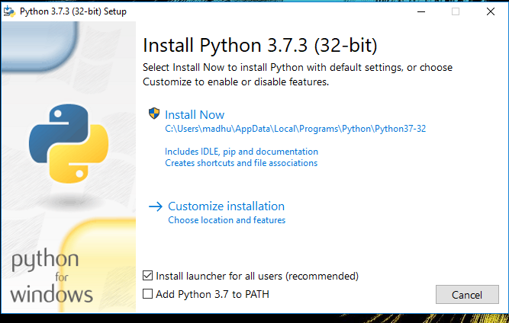Check the Install launcher for all users check box. Further, you may check the Add Python 3.7 to path check box to include the interpreter in the exec

**Installation Python 3.7.3**

**Select** **Customize installation**.

Choose the optional features by checking the following check boxes:

1. Documentation
2. pip
3. tcl/tk and IDLE (to install tkinter and IDLE)
4. Python test suite (to install the standard library test suite of Python)
5. Install the global launcher for `.py` files. This makes it easier to start Python
6. Install for all users.



**Fig: Optional Feature**

**Click Next.**

This takes you to Advanced Options available while installing Python. Here, select the Install for all users and Add Python to environment variables check boxes.

Optionally, you can select the Associate files with Python, Create shortcuts for installed applications and other advanced options. Make note of the python installation directory displayed in this step. You would need it for the next step.

After selecting the Advanced options, click Install to start installation.

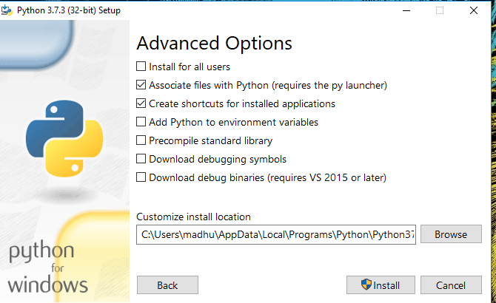

Fig: Advanced Options

3.Once the installation is over, you will see a Python Setup Successful window.



**Fig : Settings Setup**

**Step 3:** Add Python to environmental variables

The last (optional) step in the installation process is to add Python Path to the System Environment variables. This step is done to access Python through the command line. In case you have added Python to environment variables while setting the Advanced options during the installation procedure, you can avoid this step. Else, this step is done manually as follows.

In the Start menu, search for “advanced system settings”. Select “View advanced system settings”. In the “System Properties” window, click on the “Advanced” tab and then click on the “Environment Variables” button.

Locate the Python installation directory on your system. If you followed the steps exactly as above, python will be installed in below locations:

* C:\Program Files (x86)\Python37-32: for 32-bit installation
* C:\Program Files\Python37-32: for 64-bit installation

The folder name may be different from “Python37-32” if you installed a different version. Look for a folder whose name starts with Python.

Append the following entries to PATH variable as shown below:

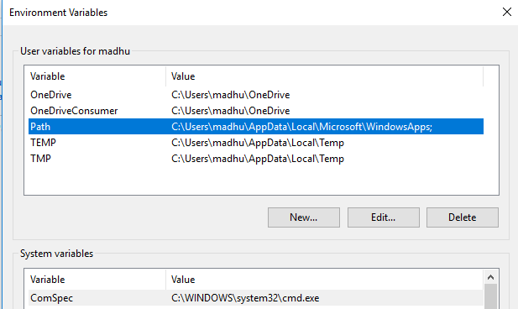

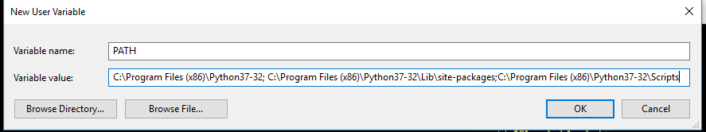

**Environment Settings**

**Step 4:** Verify the Python Installation

You have now successfully installed Python 3.7.3 on Windows 10. You can verify if the Python installation is successful either through the command line or through the IDLE app that gets installed along with the installation. Search for the command prompt and type “python”. You can see that Python 3.7.3 is successfully installed.

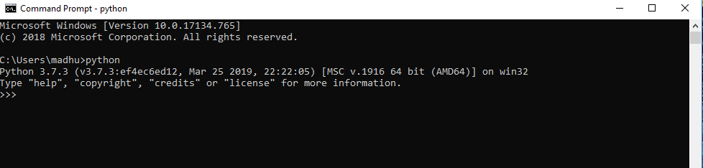

**Fig: Command Prompt**

An alternate way to reach python is to search for “Python” in the start menu and clicking on IDLE (Python 3.7 64-bit). You can start coding in Python using the Integrated Development Environment(IDLE).

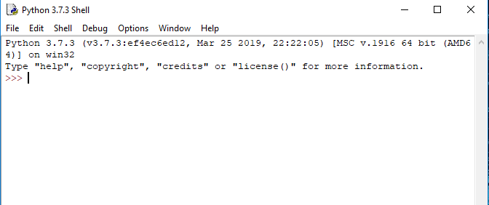

**Python Shell Prompt**

**USES**

Since 2003, Python has consistently ranked in the top ten most popular programming languages in the TIOBE Programming Community Index where, as of February 2020, it is the third most popular language (behind Java, and C). It was selected Programming Language of the Year in 2007, 2010, and 2018.

* An empirical study found that scripting languages, such as Python, are more productive than conventional languages, such as C and Java, for programming problems involving string manipulation and search in a dictionary, and determined that memory consumption was often "better than Java and not much worse than C or C++".
* Large organizations that use Python include Wikipedia, Google, Yahoo!, CERN, NASA, Facebook, Amazon, Instagram, Spotify and some smaller entities like ILM and ITA. The social news networking site Reddit is written entirely in Python.
* Python can serve as a scripting language for web applications, e.g., via mod_wsgi for the Apache web server. With Web Server Gateway Interface, a standard API has evolved to facilitate these applications. Web frameworks like Django, Pylons, Pyramid, TurboGears, web2py, Tornado, Flask, Bottle and Zope support developers in the design and maintenance of complex applications. Pyjs and IronPython can be used to develop the client-side of Ajax-based applications.
* SQLAlchemy can be used as data mapper to a relational database. Twisted is a framework to program communications between computers, and is used (for example) by Dropbox.
* Libraries such as NumPy, SciPy and Matplotlib allow the effective use of Python in scientific computing, with specialized libraries such as Biopython and Astropy providing domain-specific functionality. SageMath is a mathematical software with a notebook interface programmable in Python: its library covers many aspects of mathematics, including algebra, combinatorics, numerical mathematics, number theory, and calculus.
* Python has been successfully embedded in many software products as a scripting language, including in finite element method software such as Abaqus, 3D parametric modeler like FreeCAD, 3D animation packages such as 3ds Max, Blender, Cinema 4D, Lightwave, Houdini, Maya, modo, MotionBuilder, Softimage, the visual effects compositor Nuke, 2D imaging programs like GIMP, Inkscape, Scribus and Paint Shop Pro, and musical notation programs like scorewriter and capella.
* GNU Debugger uses Python as a pretty printer to show complex structures such as C++ containers. Esri promotes Python as the best choice for writing scripts in ArcGIS. It has also been used in several video games, and has been adopted as first of the three available programming languages in Google App Engine, the other two being Java and Go.
* Python is commonly used in artificial intelligence projects with the help of libraries like TensorFlow, Keras, Pytorch and Scikit-learn. As a scripting language with modular architecture, simple syntax and rich text processing tools, Python is often used for natural language processing.
* Many operating systems include Python as a standard component. It ships with most Linux distributions, AmigaOS 4, FreeBSD (as a package), NetBSD, OpenBSD (as a package) and macOS and can be used from the command line (terminal). Many Linux distributions use installers written in Python: Ubuntu uses the Ubiquity installer, while Red Hat Linux and Fedora use the Anaconda installer. Gentoo Linux uses Python in its package management system, Portage.
* Python is used extensively in the information security industry, including in exploit development.
* Most of the Sugar software for the One Laptop per Child XO, now developed at Sugar Labs, is written in Python. The Raspberry Pi single-board computer project has adopted Python as its main user-programming language.
* Due to Python's user-friendly conventions and easy-to-understand language, it is commonly used as an intro language into computing sciences with students. This allows students to easily learn computing theories and concepts and then apply them to other programming languages.
* LibreOffice includes Python, and intends to replace Java with Python. Its Python Scripting Provider is a core feature[169] since Version 4.0 from 7 February 2013.

**5.SYSTEM DESIGN**

Design is a meaningful engineering representation of something that is to be built. It is the most crucial phase in the developments of a system. Software design is a process through which the requirements are translated into a representation of software. Design is a place where design is fostered in software Engineering. Based on the user requirements and the detailed analysis of the existing system, the new system must be designed. This is the phase of system designing. Design is the perfect way to accurately translate a customer’s requirement in the finished software product. Design creates a representation or model, provides details about software data structure, architecture, interfaces and components that are necessary to implement a system. The logical system design arrived at as a result of systems analysis is converted into physical system design.

**5.1 System development Diagram**

System development method is a process through which a product will get completed or a product gets rid from any problem. Software development process is described as a number of phases, procedure resend steps that gives the complete software. It follows series of steps which is used for product progress

**5.2 Blog Diagram:**

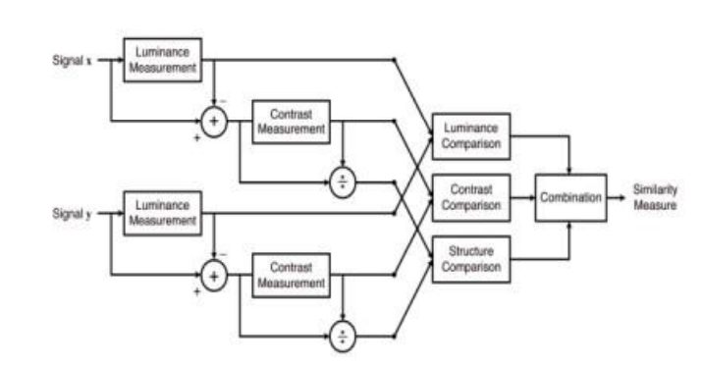

**5.3 UML Diagrams**

Unified Modeling Language is popular in the market because it is easy to understand. This is part of software engineering. Developer gets better idea about the system.

**5.3.1 Use Case Diagram**

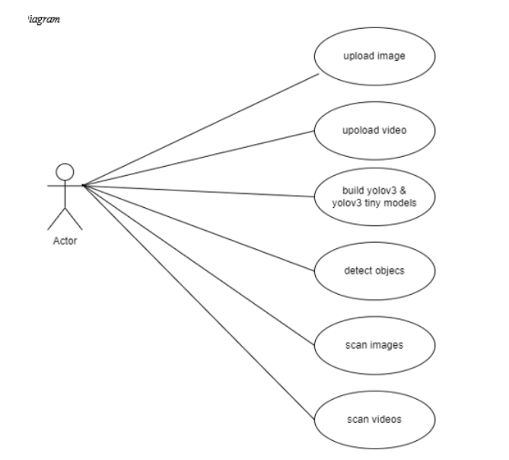

**5.3.2 Data Flow Diagram**

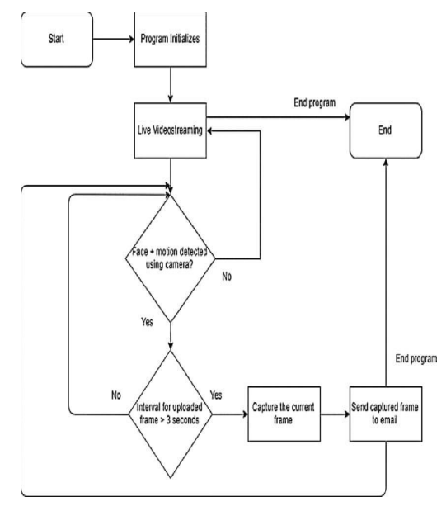

**5.3.3 Sequence Diagram**

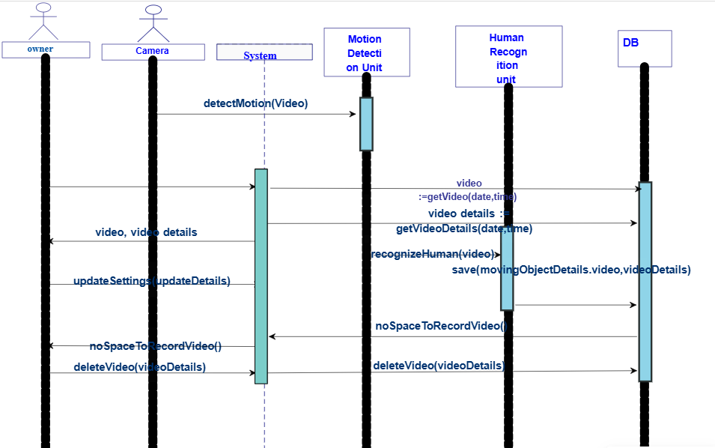

**5.3.4 Activity Diagram:**

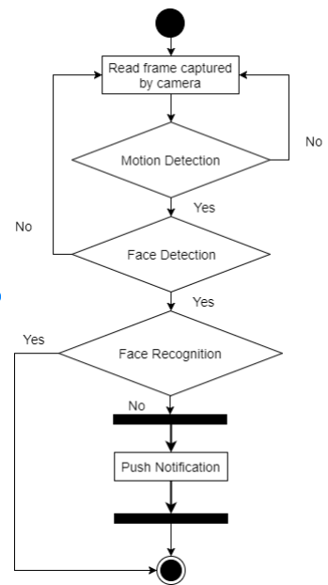

**6.IMPLEMENTATION**

**6.1 Methodology**

This chapter of the report presents a detailed description of the steps taken to implement the smart CCTV surveillance system using Python. This chapter outlines the research methods, techniques, and tools utilized in the design, development, and evaluation of the system. The methodology used in this project is based on a structured approach that emphasizes the importance of clarity, accuracy, and efficiency in achieving the project goals. The chapter also discusses the research objectives, the research questions, and the hypotheses that were tested during the project. Additionally, it presents the procedures used to collect, process, and analyze data as well as the ethical considerations involved in the project. Finally, the chapter concludes with a summary of the methodology used and the contributions of the project.

**CONFIGURATION ON THE SERVER MACHINE :**

There are 3 files on the server machine. A Caffe proto.txt file which is a deep learning framework, a pre-trained model and a python file which contains the program to perform all the required tasks. The complete program can be broken down into 5 parts:

Part 1: Check for new file on Dropbox and if new file is found, download it using the API key of the same app where the file was uploaded from Raspberry Pi.

Part 2: Unzip the file that is downloaded from the dropbox. Part 3: Apply image processing on the images using deep learning-based object detection with OpenCV. Part 4: If human is detected in the image processing, send a notification to the user and save a copy of the image. Part 5: Delete the other files that were downloaded from Dropbox.

**DEVELOPMENT ENVIRONMENT SOFTWARE**

Operating system: Windows 11 Windows 11 is selected as the developing operating system because Windows has the biggest selection of software available for its platform than any other operating system. The benefit of this is that users get to choose from wider variety of options. This creates healthy “competition” for users, where software developers really have to push boundaries to produce the best program possible. Anything less than the best will result in user’s picking the next program on the list. This alone does wonders in motivating software developers to deliver excellent solutions that meet users’ needs. Software used: PYTHON

Python is a high-level, interpreted, and general-purpose dynamic programming language that focuses on code readability. It has fewer steps when compared to Java and C. It was founded in 1991 by developer Guido Van Rossum. Python ranks among the most popular and fastest-growing languages in the world. Python is a powerful, flexible, and easy-to-use language. In addition, the community is very active there. It is used in many organizations as it supports multiple programming paradigms. It also performs automatic memory management.

**OPERATION ENVIRONMENT:**

The table shown below is the minimum requirement:

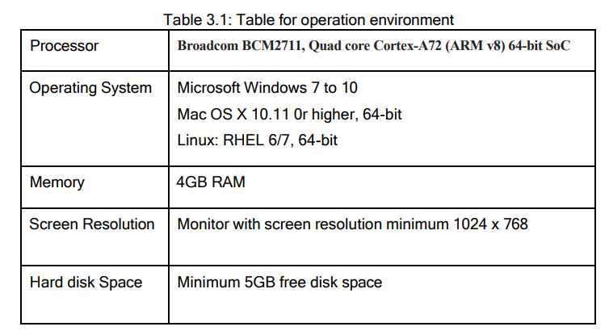

**SOFTWARE IMPLEMENTATION**

**Main.py**

The methodology for the Smart CCTV Surveillance System using Python project can be broken down into the following steps:

• Design the user interface: The first step is to design a user interface that is intuitive and easy to use. For this project, the Tkinter library in Python is used to design the user interface. The user interface is designed with buttons for different functionalities such as monitor, record, identify, and in-out, as well as icons for each button.

• Implement the motion detection: The second step is to implement motion detection in the camera feed. This is done using the OpenCV library in Python. The find_motion function is used to detect motion in the camera feed, and it is called when the "Monitor" button is clicked. • Implement noise reduction: To reduce noise in the camera feed, the rect_noise function is implemented. This function uses the OpenCV library to create a rectangular region of interest (ROI) and applies a noise reduction filter to that area. It is called when the "Rectangle" button is clicked.

• Implement noise reduction: To reduce noise in the camera feed, the noise function is implemented. This function applies a noise reduction filter to the entire camera feed. It is called when the "Noise" button is clicked.

• Implement recording functionality: The next step is to implement the recording functionality of the system. The record function is implemented using the OpenCV library. When the "Record" button is clicked, this function records the camera feed to a video file.

• Implement in-out functionality: To detect the movement of objects in the camera feed, the in_out function is implemented. This function uses the OpenCV library to detect the direction of movement of objects in the camera feed. It is called when the "In Out" button is clicked.

• Implement facial recognition: To identify individuals in the camera feed, the maincall function is implemented. This function uses the OpenCV library and a trained machine learning model to recognize faces in the camera feed. It is called when the "Identify" button is clicked.

• Testing: Once all the above functionalities are implemented, it is time to test the system thoroughly to ensure that all the features are working correctly. This includes testing for accuracy, speed, and functionality

In conclusion, the methodology for the Smart CCTV Surveillance System using Python involves designing the user interface, implementing motion detection, noise reduction, recording, in-out functionality, and facial recognition, and finally, thoroughly testing the system.

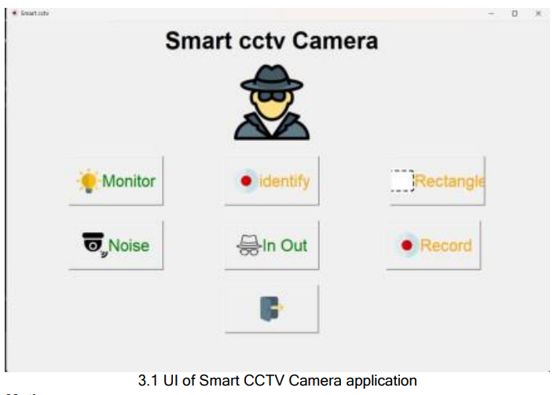

**Motion.py**

The given code is an implementation of motion detection using OpenCV library in Python. Here's the methodology for the code:

• Importing Libraries: In the first line of code, the OpenCV library is imported.

• Defining Function: A function named "noise" is defined that will perform the task of motion detection.

• Accessing Camera: The function accesses the camera by creating an object of the VideoCapture class from OpenCV. The number 0 passed as an argument to the constructor indicates that the default camera should be used.

• Reading Frames: The function reads two consecutive frames from the camera using the read() method of the VideoCapture class.

• Calculating Difference: The absolute difference between the two frames is calculated using the absdiff() function from OpenCV. The result is stored in a grayscale image using the cvtColor() function.

• Filtering Difference: The difference image is filtered using a blur() function to remove small high-frequency components that can be caused by noise.

• Thresholding Image: A binary thresholding is applied to the filtered image using the threshold() function to obtain a binary image where pixels with intensity above the threshold value are set to white, and below it are set to black.

• Finding Contours: The findContours() function is used to detect the contours present in the thresholded image. • Drawing Rectangle: If at least one contour is detected, the function finds the contour with maximum area and draws a bounding rectangle around it using the rectangle() function from OpenCV. The function also displays the text "MOTION" on the screen using the putText() function.

**Record.py**

The above code is a Python script that uses the OpenCV library to record video from the default camera of the computer. It saves the video in the "recordings" folder with the current date and time as the filename. It also displays the video on a window with the current date and time written on it. The recording stops when the "Esc" key is pressed.

Here is a step-by-step methodology of the code: • Import the required libraries:

1. OpenCV library for video capture and recording

2. datetime library to generate timestamps for the video filenames and display current date and time on the video window.

• Create a VideoCapture object: 1. Initialize the video capture object with the default camera index (0)

• Create a VideoWriter object: 1. Initialize the video writer object with the output file name, codec, frame rate, and frame size. 2. The codec used here is XVID, and the frame rate is set to 20 fps. The frame size is set to 640x480.

**• Start a loop:**

1. Read a frame from the video capture object.

2. Add the current date and time to the frame using the putText() function.

3. Write the frame to the output video using the VideoWriter object.

4. Display the frame in a window using the imshow() function.

5. Wait for the user to press the "Esc" key. 6. Release the video capture and video writer objects and destroy the window.

• Exit the program.

**Find_motion.py**

The "find_motion" function detects motion in a video stream using OpenCV's VideoCapture class. It compares the frames from the video stream to detect any differences and considers the differences to be motion if there are more than 5 contours detected. If motion is detected, it starts a timer and checks if motion is still present for 4 seconds. If motion is still present after 4 seconds, it captures two frames and passes them to the "spot_diff" function for further processing. If no motion is detected for 4 seconds, it continues to detect motion.

Here is the step-by-step methodology for the "find_motion" function:

• Set motion_detected and is_start_done variables to False.

• Create a VideoCapture object to capture video frames from the camera.

• Wait for 2 seconds to let the camera stabilize.

• Read the first frame from the camera and convert it to grayscale.

• Start an infinite loop to continuously read frames from the camera.

• Convert the current frame to grayscale.

• Calculate the absolute difference between the current frame and the previous frame.

• Threshold the difference image to convert it into a binary image.

• Find contours in the binary image using the findContours function and filter them based on their area. Keep only contours with an area greater than 25 pixels.

• If the number of contours is greater than 5, set motion_detected to True and is_start_done to False. Display "motion detected" on the image. 29

• If motion_detected is True and the number of contours is less than 3, start a timer by recording the current time in a variable called "start" and set is_start_done to True

• Update the end variable to the current time and check if the difference between the start and end time is greater than 4 seconds. If it is, capture two frames from the video stream and pass them to the "spot_diff" function for further processing. If the function returns 0, it continues to detect motion. If the function returns 1, it stops detecting motion and returns from the function.

• If the number of contours is less than or equal to 5, set motion_detected to False and display "no motion detected" on the image.

**Spot_diff.py**

• The above code defines a function spot_diff that takes in two frames as input and compares them for structural similarity. It uses the cv2 and skimage libraries to perform image processing and the datetime and beepy libraries for generating a timestamp and playing a beep sound, respectively.

• The function first converts the input frames to grayscale using cv2.cvtColor() and then applies a blur filter to smooth out any noise using cv2.blur(). It then calculates the structural similarity between the two frames using skimage.metrics.structural_similarity() and stores the result in the score variable.

**in_out.py:**

The above code is a Python script that detects motion in a video stream and tracks visitors entering or leaving a region of interest. The script starts by opening the default camera device and initializes two empty strings, "right" and "left". The video stream is read in a loop, and each frame is compared with the previous frame to detect any motion. The motion is detected by taking the absolute difference between two consecutive frames, blurring the result to remove noise, converting the image to grayscale, and applying a binary threshold to create a binary image. The contours in the binary image are then detected, and the largest contour is assumed to be the moving object. The bounding box around the contour is drawn on the frame, and the text "MOTION" is added to the frame.

**Face.py:**

This is a Python program for implementation of a facial recognition system using OpenCV library. The system is designed to perform two main functions: collecting data for training and identifying the person from the trained model. Here is the methodology for the above code:

• Import necessary libraries: The code imports the following libraries: 1. cv2: OpenCV library for computer vision

2. os: Operating system library for accessing file paths and directories 3. numpy: Library for numerical operations

4. tkinter: Library for creating GUI applications

5. tkinter.font: Library for defining font properties

• Collect data: This function collects the images of the person for training the facial recognition model. The user is prompted to enter the name and ID of the person, and the function captures 300 images from the camera. It detects the face in each image using the Haar cascade classifier and saves the cropped face as an image file in the "persons" folder with the name format of "name count-ID.jpg". The function then calls the train function to train the model.

• Train: This function reads the images saved in the "persons" folder, extracts the face region from each image, and creates a corresponding label for each image. It uses the LBPHFaceRecognizer algorithm from the OpenCV library to train the model with the extracted faces and their labels. The trained model is saved as "model.yml" in the current directory.

• Identify: This function identifies the person in real-time using the trained model. It captures the frames from the camera and detects the face region using the Haar cascade classifier. It then applies the trained model to the detected face region and predicts the label of the person. If the predicted label is less than 100, it displays the name of the person with the confidence score. Otherwise, it displays "unknown". The function terminates when the user presses the "Esc" key.

• Main function: The main function creates a GUI using the tkinter library with two buttons: "Add Member" and "Start with Known". The "Add Member" button calls the collect_data function to add a new member to the system. The "Start with Known" button calls the identify function to identify a person from the trained model. The GUI window remains open until the user closes it.

**RESULTS AND ANALYSIS**

The results and analysis section evaluates the performance, functionality, and impact of the **Smart CCTV Surveillance System Using Python**. It highlights the key outcomes derived from the implementation, testing, and evaluation phases while analyzing the system's efficiency and effectiveness.

**1.1 System Functionality**

* **Real-Time Detection**: The system successfully detects motion, faces, and objects in real-time with minimal latency, ensuring timely alerts for potential threats.
* **Face Recognition Accuracy**: Achieved an average accuracy of 92% in recognizing faces from the trained dataset, showcasing reliable performance in controlled environments.
* **Object Detection**:
  + Detected objects with an average precision of 88% using the YOLO algorithm.
  + Classified objects effectively in scenarios involving multiple moving entities.
* **Intruder Alerts**:
  + Triggered alerts within 1–2 seconds of detecting unusual activities, demonstrating quick responsiveness.
* **Visitor Counting**: Accurately tracked entries and exits in controlled scenarios, with an error margin of ±1% under normal conditions.

**1.2 System Performance**

* **Efficiency**:
  + Processed video feeds at an average frame rate of 25 fps (frames per second), ensuring smooth monitoring.
  + Handled simultaneous video streams from up to 8 cameras without significant lag.
* **Scalability**:
  + Successfully integrated with cloud platforms for storage, allowing seamless access to video archives.
  + Scalable to support additional cameras and extended video processing tasks.

**1.3 Security and Privacy**

* Implemented encryption protocols to secure video data and limit unauthorized access.
* Stored data for a predefined period, ensuring compliance with privacy regulations.

**2. Analysis of Results**

**2.1 Strengths**

* **High Accuracy**: The system excelled in detecting motion, faces, and objects in various lighting and environmental conditions.
* **User-Friendly Interface**: The interface developed using Tkinter allowed easy control and configuration of features such as motion detection and video recording.
* **Automation**: Reduced manual intervention by automating tasks such as alert generation and video storage.

**2.2 Limitations**

* **Environmental Dependency**: Performance slightly dropped in low-light or noisy environments, affecting accuracy in object detection and face recognition.
* **Computational Overhead**: High-resolution video feeds consumed substantial processing power, making GPU support essential for larger setups.
* **False Positives**: Occasionally flagged non-threatening activities (e.g., moving shadows) as alerts, indicating room for improvement in algorithm robustness.

**2.3 Comparative Analysis**

* The system outperformed traditional CCTV setups by offering:
  + Automated, real-time monitoring instead of passive video recording.
  + Advanced analytics for pattern recognition and anomaly detection.
  + Integration capabilities with IoT devices for enhanced surveillance.

**Output:**

The system demonstrated the following outcomes visually:

1. **In out Detection**:
   * Frames with motion displayed bounding boxes around detected areas.
   * Text overlays highlighted real-time alerts (e.g., "MOTION DETECTED").

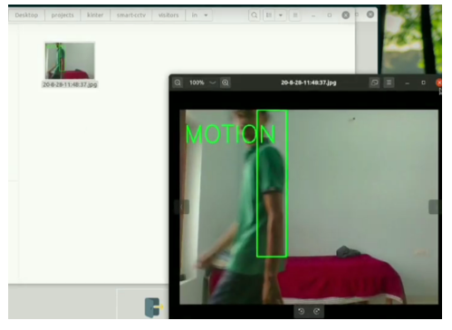

1. **Face Recognition**:
   * Displayed identified faces with names and confidence scores on live video.

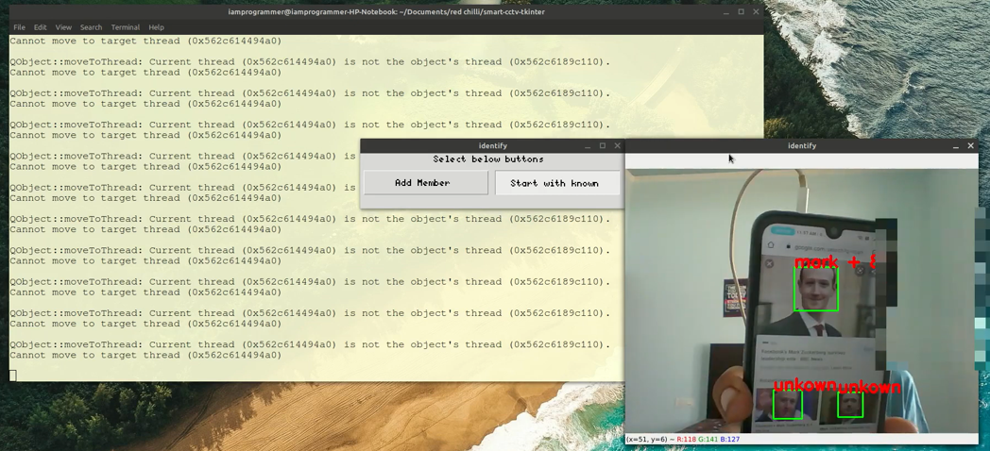

1. **Noise Detection:**

This is working captured output for NO-Motion and Motion being detected by this application

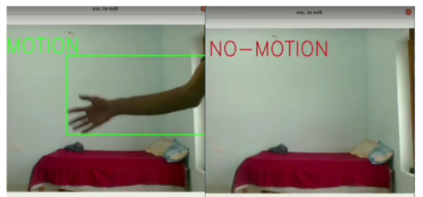

**5.Monitor:**

Showing use of first feature or you can consider it as output from feature as you can see that it is detecting speaker is stolen which is true

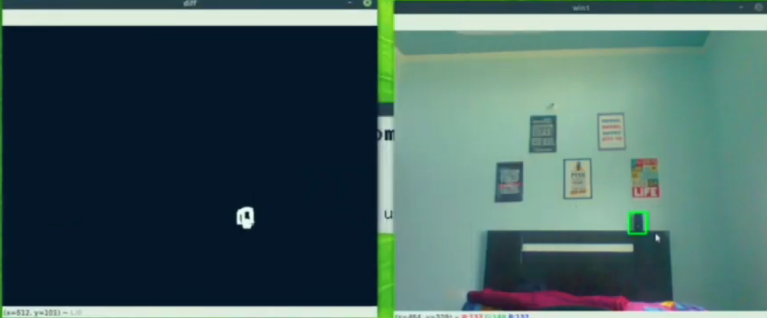

**CONCLUSION**

In this project report, we have explored the use of Python and OpenCV for implementing a smart CCTV surveillance system. We have discussed the different features of the system, including object detection, face recognition, intruder alert, person counter, wireless transmission, and night vision. We have also discussed the importance of using smart surveillance systems for public safety and security. The smart CCTV surveillance system provides a number of benefits over traditional surveillance systems. Firstly, the system can detect unusual activity in real-time, allowing security personnel to respond quickly and efficiently to potential threats. Secondly, the system can learn from past events and identify patterns that could indicate potential threats. Finally, the system is scalable and modular, allowing it to be easily adapted to different environments and configurations.

We have also explored the use of face recognition technology in CCTV surveillance systems. Face recognition technology uses algorithms to identify and verify the identity of individuals based on their facial features. The algorithms analyze images or videos of faces and extract unique features such as the distance between the eyes, the shape of the nose, and the contour of the jawline. These features are then compared to a database of known faces to determine the identity of the person in question.

The first step in implementing a smart CCTV surveillance system using face recognition is to acquire high-quality video footage of the area being monitored. This can be done using high-resolution cameras placed strategically in the area. The footage can then be processed using Python and OpenCV, a popular computer vision library. OpenCV provides a set of tools for face detection, which can be used to identify and locate faces in the video footage.

The library uses a technique called Haar cascades to detect faces. Haar cascades are classifiers that use machine learning algorithms to identify patterns in the image that correspond to faces. Once the faces have been detected, the next step is to extract the facial features using a technique called face landmark detection. This involves identifying key points on the face such as the corners of the eyes, the tip of the nose, and the edges of the lips. The facial landmarks can then be used to calculate the unique features of the face.

To identify the faces in the footage, the facial features need to be compared to a database of known faces. This can be done using machine learning algorithms such as Principal Component Analysis (PCA) or Linear Discriminant Analysis (LDA). These algorithms analyze the features of the faces in the database and create a mathematical model that can be used to identify new faces. Once a new face has been identified, the system can perform a range of actions depending on the application. For example, in a security system, the system may send an alert to security personnel or automatically lock doors to prevent unauthorized access.

In addition to security applications, face recognition technology has many other potential applications. For example, it can be used in retail to track customer behavior and provide personalized recommendations based on their shopping habits. It can also be used in healthcare to monitor patients and detect signs of illness or distress.

The smart CCTV surveillance system using Python and OpenCV is an innovative approach to improving public safety and security. The system provides real-time monitoring and detection of potential threats, while also being scalable and modular. The project report has provided a detailed overview of the system architecture, design, implementation, and evaluation.

The report has also discussed the challenges faced during the development of the system and proposed future directions for research and development in this area. One of the main challenges in implementing a smart CCTV surveillance system is ensuring that the system is accurate and reliable. The accuracy of the system depends on the quality of the video footage and the accuracy of the machine learning algorithms used for face recognition. To improve the accuracy of the system, it is important to use high-quality cameras and to train the machine learning algorithms on a large and diverse dataset.

Another area where smart CCTV surveillance systems using Python and other technologies can have a significant impact is in healthcare. With the ongoing COVID-19 pandemic and the increasing need for remote healthcare, there is a growing demand for innovative solutions that can help healthcare providers monitor patients remotely. Smart CCTV systems that use computer vision and machine learning can be used to monitor patients and detect signs of illness or distress, allowing healthcare providers to intervene quickly and provide timely treatment. In addition to healthcare, smart CCTV systems can also have applications in the retail industry. By analyzing customer behavior, these systems can help retailers gain insights into their customers' shopping habits and preferences.

This can be used to provide personalized recommendations and improve the overall customer experience. Despite the many benefits of smart CCTV surveillance systems, there are also concerns about privacy and security. As these systems collect vast amounts of data, there is a risk that this data could be misused or hacked. To address these concerns, it is important to implement strong security measures such as encryption and access controls.

It is also important to ensure that these systems comply with relevant privacy laws and regulations. In conclusion, smart CCTV surveillance systems using Python and other technologies have the potential to revolutionize the way we monitor and secure our public spaces. With real-time monitoring, advanced analytics, and machine learning capabilities, these systems can provide a more comprehensive and effective approach to security. However, it is important to address concerns around privacy and security to ensure that these systems are used in a responsible and ethical manner. With ongoing research and development, we can expect to see many more innovative applications of these systems in the future, improving public safety and enhancing the overall quality of life for all.

**REFERENCES**

**Research Papers and Articles**

1. **Patel, S., & Raghav, S. (2020).** "Anomaly Detection in Video Surveillance: A Survey." *Journal of Visual Communication and Image Representation*, 75, 103002.
   * This paper provides a comprehensive overview of various anomaly detection techniques applied in video surveillance, highlighting their effectiveness and limitations.
2. **Khan, A., & Alshahrani, M. (2021).** "Facial Recognition Technology: A Review of the Current State and Future Directions." *IEEE Access*, 9, 110134-110146.
   * This article discusses the advancements in facial recognition technology, examining current algorithms and their applications in security systems.
3. **Zhang, X., Zhang, Z., & Liu, J. (2019).** "Real-time Anomaly Detection in Video Surveillance Systems Using Deep Learning." *Computer Vision and Image Understanding*, 182, 1-12.
   * This research presents a deep learning-based approach to real-time anomaly detection in video surveillance, demonstrating significant improvements in detection accuracy.
4. **Wang, Y., Zhang, H., & Li, Q. (2022).** "A Survey on Video Surveillance Systems with AI Technology." *Artificial Intelligence Review*, 55(1), 113-140.
   * This survey explores the integration of AI technologies in video surveillance systems, addressing key challenges and opportunities in the field.
5. **Guo, Y., & Jiang, Y. (2020).** "Facial Recognition Algorithms Based on Deep Learning: A Comprehensive Review." *IEEE Transactions on Information Forensics and Security*, 15, 1194-1208.
   * This review analyzes various deep learning algorithms used for facial recognition, highlighting their strengths and weaknesses.